Project 16

1- What is ssh?
SSH, also known as Secure Socket Shell, is a network protocol that provides administrators with a secure way to access a remote computer

2- What is the default port for ssh? 22

3- Can the default port be changed?
Yes, it can be changed for security reason. Scammers are always looking for the default port 22 for instance and once that is changed it becomes evident that moving off the standard ssh port reduces your server’s profile of being scammed or hacked and so on.

4- What is the configuration file for ssh?
ssh_config file

5- how do you check which port the ssh is configured on?
Type the command cat /etc/ssh/ssh_config and grep for Port.

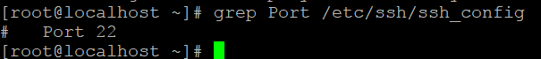

6- What is the difference between telnet and ssh?
Both serve the same purpose but what distinquishes them is for security reasons as follows

--SSH is more secure compared to Telnet
--SSH encrypts the data while Telnet sends data in plain text
--SSH uses a public key for authentication while Telnet does not use any authentication
--SSH adds a bit more overhead to the bandwidth for security reasons as compared to Telnet

7- what is the command to keep ssh daemon on at next reboot?
You type in the command chkconfig sshd on

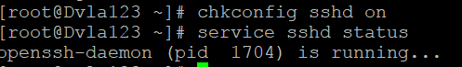

8- How do you disable root login thru ssh?
Before you start with the process of disabling root login you first need to add a user or administrator that can ssh into the server and inherit root privileges and become the super user (root).After adding another user you type the command—echo ‘user ALL=(ALL) ALL’ >> /etc/sudoers to get all the root privileges to new user

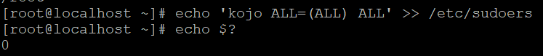

Next , SSH to the server with the new user to make sure that the login works. Once, the you are able to SSH to the sever verify that you can swith user to root with the new user.

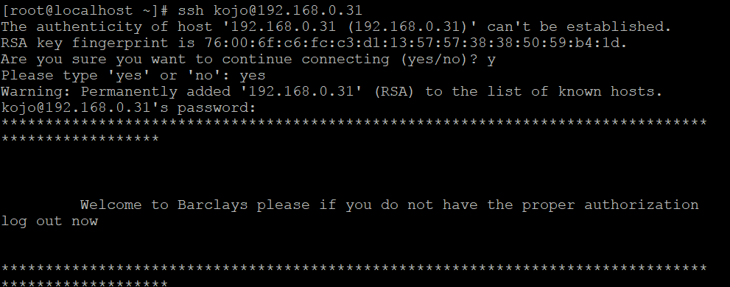

Then to disable root SSH login , you vi into the sshd_config file by typing the command---- vi /etc/ssh/sshd_config and change where it says “PermitRootLogin yes” to no then save and quit file the file

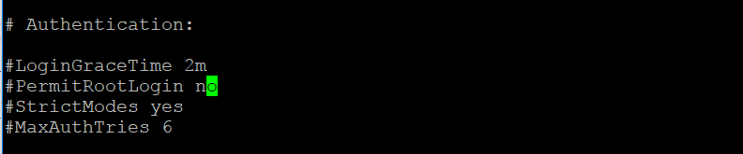

The Final step is to make sure that you are logged into the box with another shell before restarting sshd to avoid locking yourself out of the server. Run the command /etc/init.d/sshd restart to complete the final step.

9- Is it possible to login thru ssh without password? if no/yes why?
Yes it is because you generate a private and public keys based authentication which replaces the password anytime you send or copy a file to another server through SSH

10- How do you set up a key based authentication thru ssh? To setup a key you follow the following steps to the below screenshot

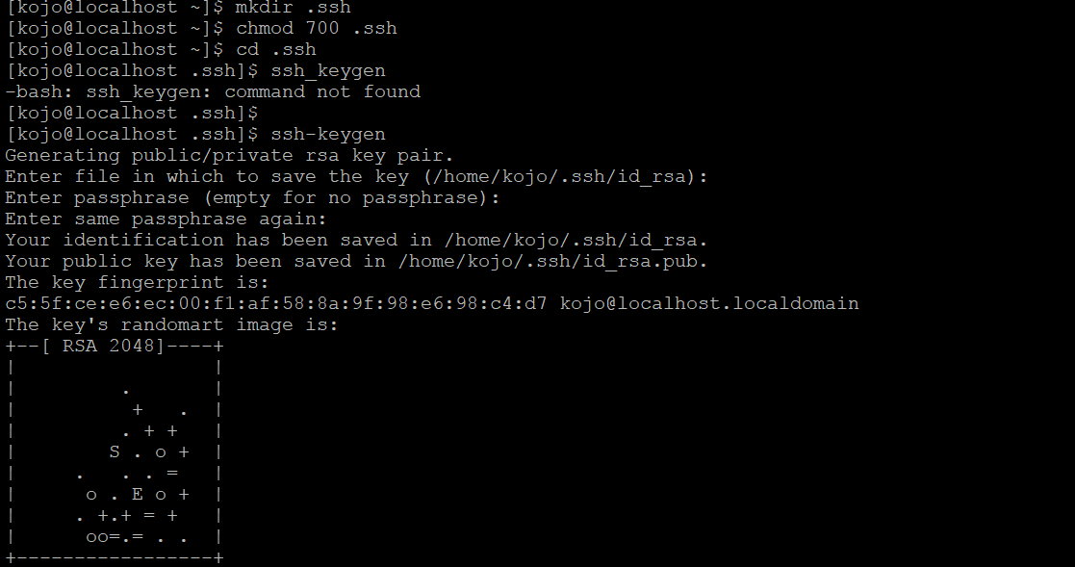

11- what is a tar file?
TAR is a software utility used for collecting several files into one archive file, including videos and images, in one for easier distribution or archiving.

12- What is the extention of a tarball file? Gunzip. This means that all the files have been packed into a tar file, which has been compressed with gzip to save space.

13- what is gunzip?
Gunzip is a utility tool or command used to compress or expand files.

14- login to your server, create a tarbal file with the content of your home directory.

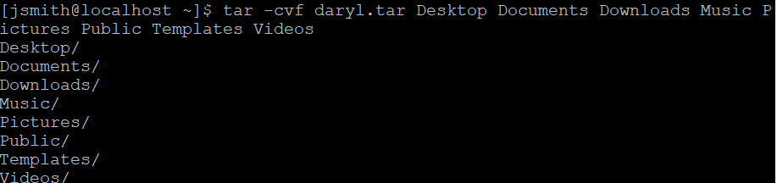

The tarball should be called yourname.tar

15- use gunzip tool to compress your tarball file.

16- securely copy your compressed file to my server in /tmp (96.245.84.63 user=class3, passwd=school1)

